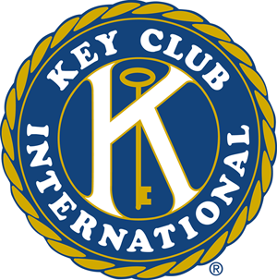
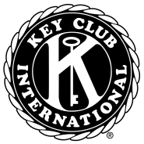

In This Issue…
Halloween Safe House…………….1

Key Club & the English Dept…2

UNICEF…………2

Trick or Treat Trot………………3

Blood Drive Registration…3

Spare Change
Save Babies…4

Reminders…….4

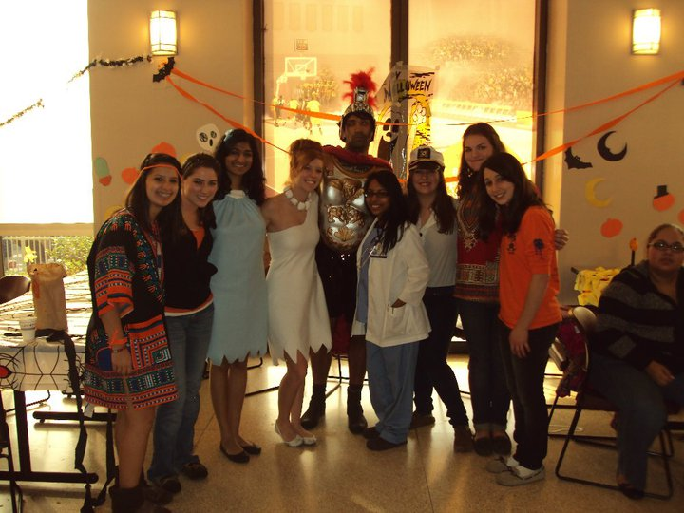

Lane Tech Key Club partnered with Loyola’s Circle K (the college level of Key Club) in a community effort to teach children safety tips while trick-or-treating.

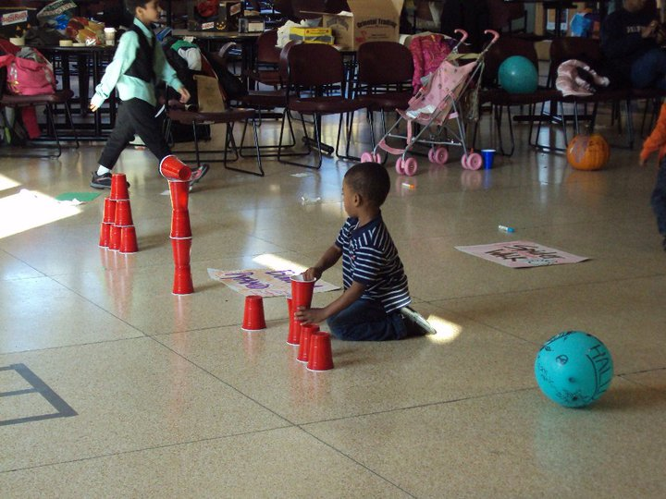

LT Key Clubbers dressed in their favorite costumes as they help set up for the popular event. It was a lot of fun to see the little kids dress up as well…very adorable actually!
The event was a success, and Key Club plans to partner with Loyola Circle K in the near future. Good job!
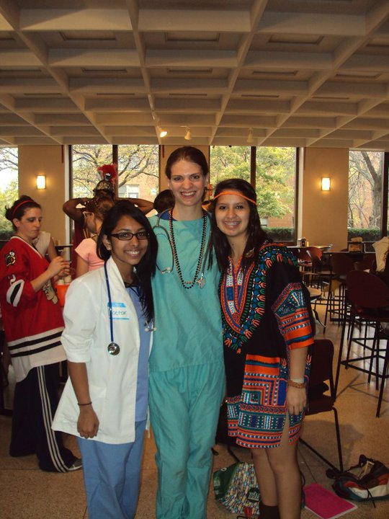

leadership.
International boasts a membership of more than 12,000 members on more than 525 campuses around the globe.
Circle K International is comprised of college and university students who are responsible citizens and leaders with a lifelong commitment to community service worldwide. As a collegiate organization, Circle K International holds the promise of today’s student becoming tomorrow’s leader. It exists to meet the personal needs of the individual collegian through the qualities of leadership, the rewards of service, and the unique spirit of friendship. Leadership, service and fellowship; the embodiment of the three tenets premier collegiate service organization. A member of the Kiwanis family, Circle K International boasts a membership of more than 12,000 members on more than 525 campuses around the globe.
Circle K International is comprised of college and university students who are responsible citizens and leaders with a lifelong commitment to community service worldwide. As a collegiate organization, Circle K International holds the promise of today’s student becoming tomorrow’s leader. It exists to meet the personal needs of the individual collegian through the qualities of leadership, the rewards of service, and the unique spirit of friendship. Leadership, service and fellowship; the embodiment of the three tenets of Circle K International are necessary to shape the future, realized in the colleges and universities of today.
Circle K International is the world’s premier collegiate service organization. A member of the Kiwanis family, Circle K International boasts a membership of more than 12,000 members on more than 525 campuses around the globe.
Circle K International is comprised of college and university students who are responsible citizens and leaders with a lifelong commitment to community service worldwide. As a collegiate organization, Circle K International holds the promise of today’s student becoming tomorrow’s leader. It exists to meet the personal needs of the individual collegian through the qualities of leadership, the rewards of service, and the unique spirit of friendship. Leadership, service and fellowship; the embodiment of the three tenets

1 The Official Newsletter of Lane Tech Key Club
LT Key Club Teaches Halloween Safety
Official Newsletter of Lane Tech Key Club
Volume 1 Issue 6 October 2010

K E Y C L U B
Maggie’s Musings


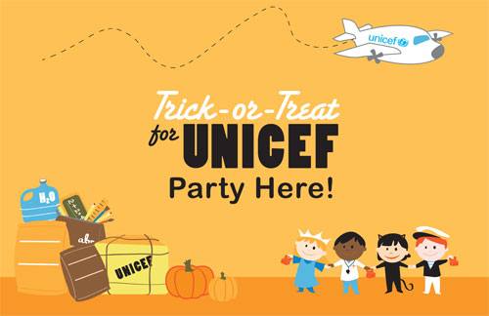

Trick or Treating with UNICEF
Key Club, Key Club, Where Art Thou?
On October 22nd, a few of our Key Club members gave up their day off from school to lend a helping hand to our Lane Tech English Department.
Members received service hours for diligently helping the English Department with their tasks.
Thank you!

Lane Tech Key Club: Thank you so much for collecting money to help the children in Uruguay! By collecting spare change from family members, friends, and classmates, you made trick-or-treating with UNICEF a wonderful success here at Lane. The boxes are due Wednesday, November 3rd, but we already have a large quantity of boxes turned in by you! Thank you so much! You guys are amazing and, we are sure that the kids in Uruguay will have a smile on their faces thanks to your generosity!

2 The Official Newsletter of Lane Tech Key Club

- 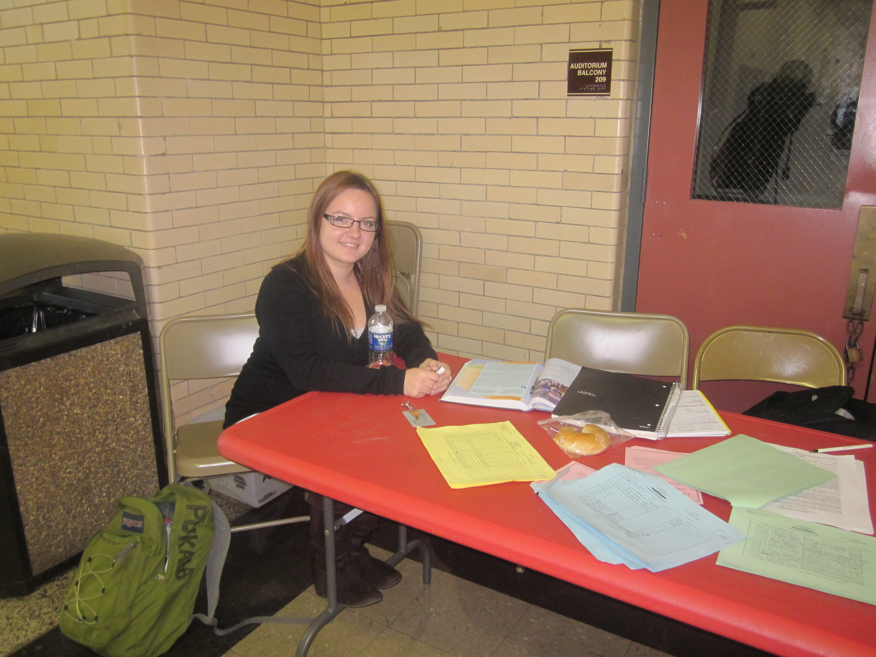
Lane Tech Key Club is hosting its semi-annual blood drive with Life Source from November 8th until November 10th. In the meantime, Lane Tech Key Clubbers gave up their lunch periods to help register willing blood donors. Anna Pukala pictured above claims that she is “amazed at how many wonderful people are willing to donate blood at our school”. Other members, such as Bohdana Bahriy and Aleksandra Bursac, pictured below, believe that “the blood drive is a great way to raise Key Club awareness in our school”. Blood drive registration continues until November 5th.
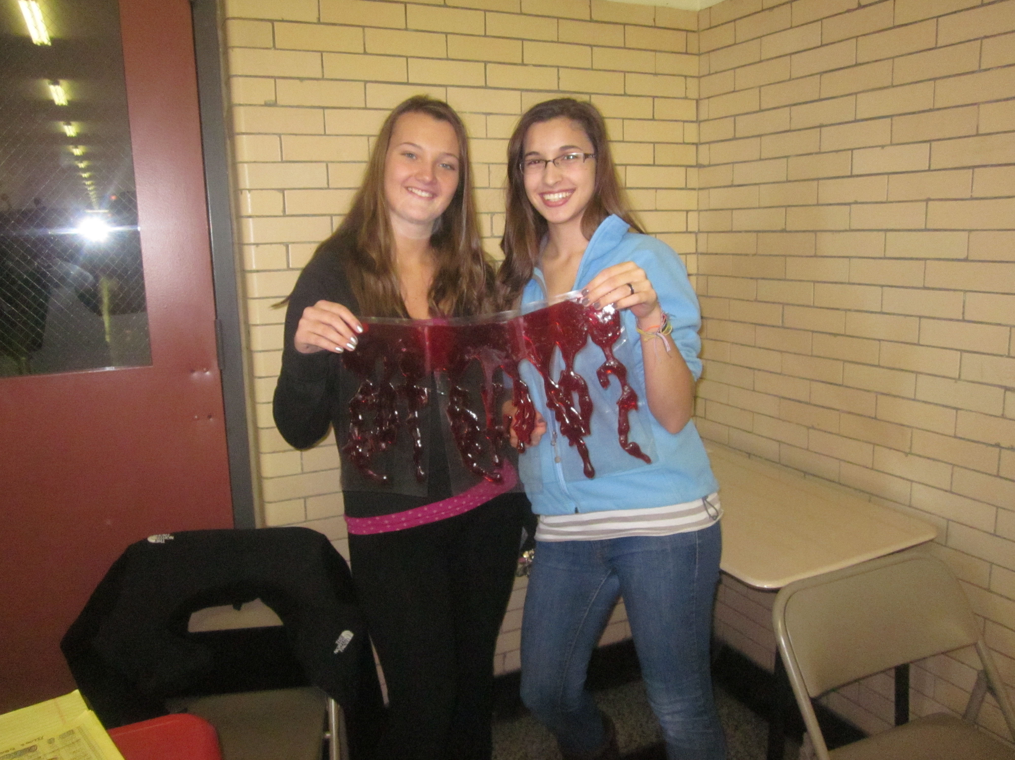

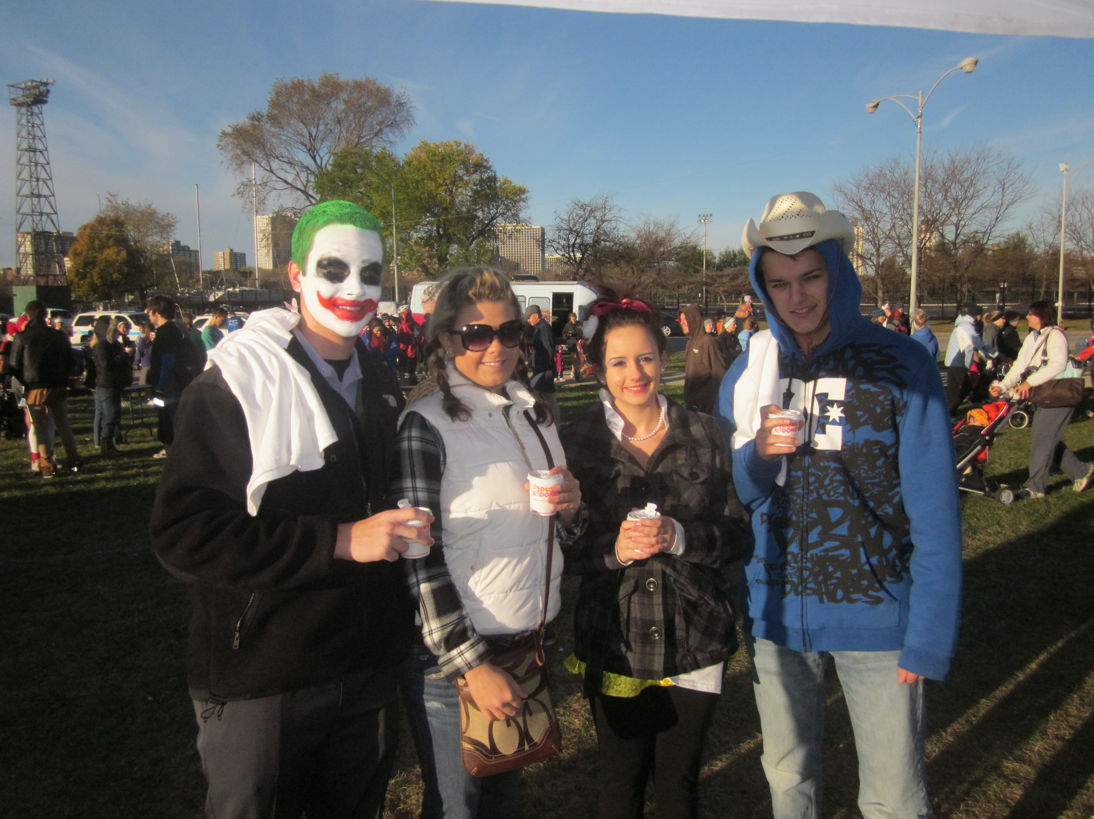
On a cold and windy morning on Halloween, Lane Tech Key Clubbers woke up bright and early to help out at the 23rd annual Trick-or-Treat Trot at Montrose Harbor. Our duties ranged from passing out bagels and water to runners to guiding runners where to go.
Some Key Clubbers, such as Alexander Prazuch, Magdalena Mastalerz, Dominica Duda, and Artur Glowinski, dressed up in spirit of the holiday.
Awesome job you guys!

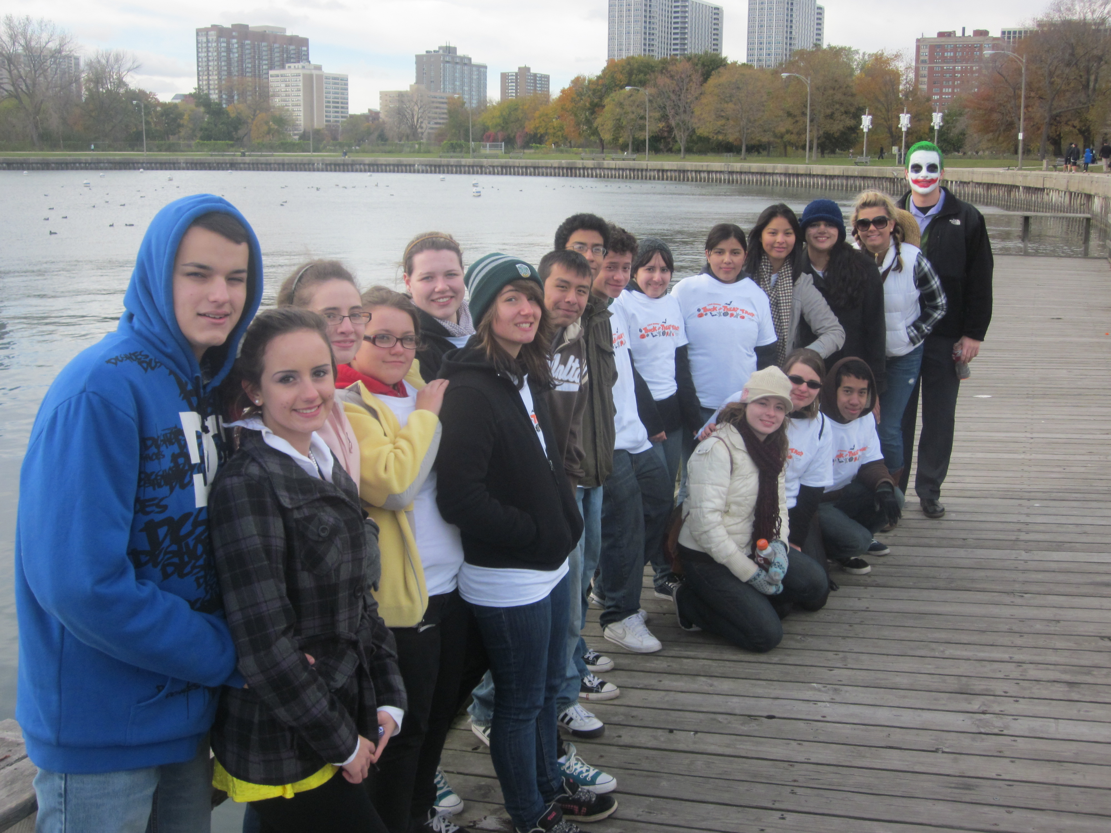

We Want YOU to Donate Blood!
Key Club Trots on Halloween
K E Y C L U B
3 The Official Newsletter of Lane Tech Key Club

